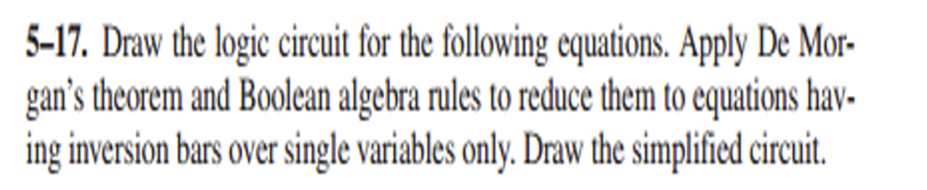

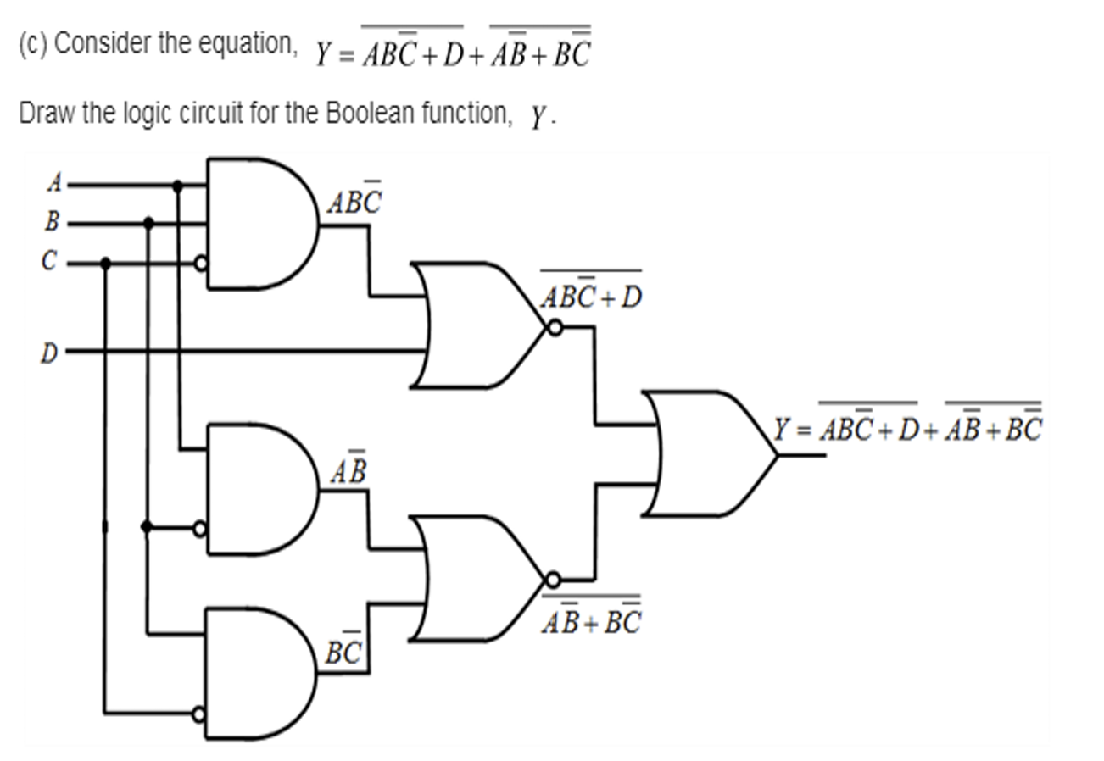

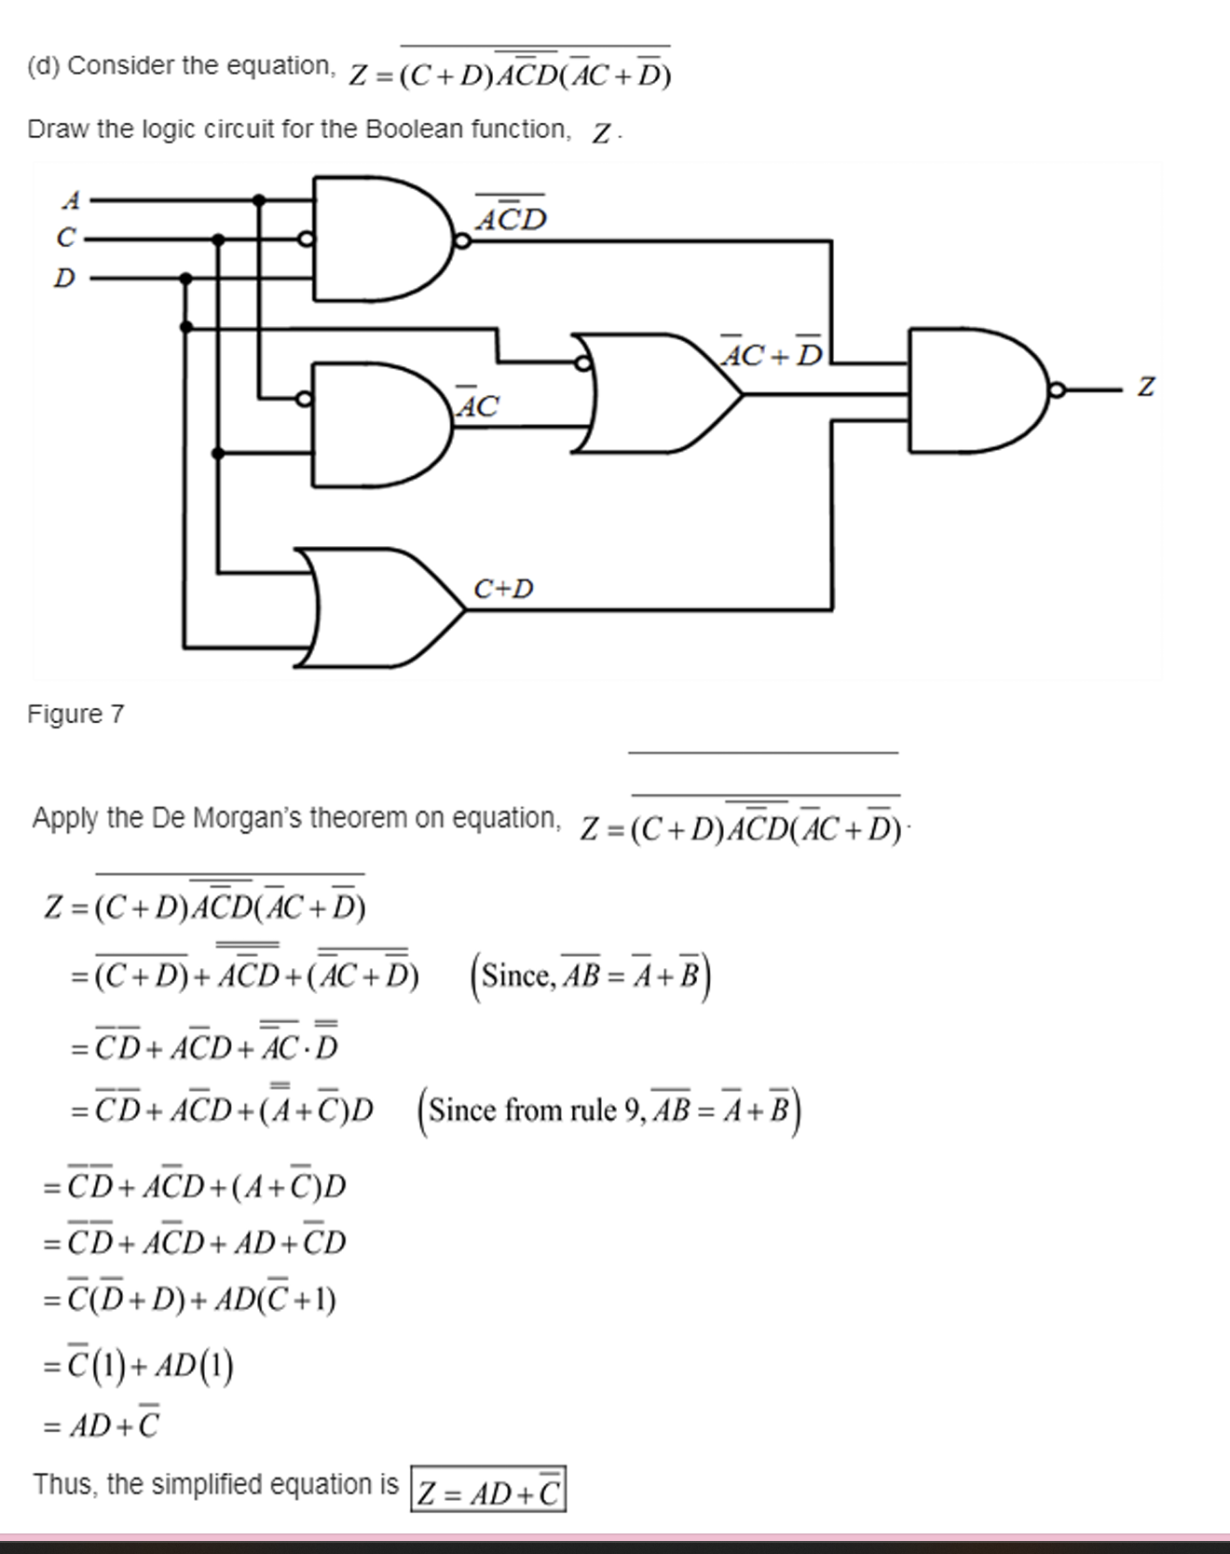

**Sum Of Product (SOP)**

Sum of product form is a form of expression in Boolean algebra in which different product terms of inputs are being summed together. This product is not arithmetical multiply, but it is Boolean logical AND and the Sum is Boolean logical OR.

#### **Example:**

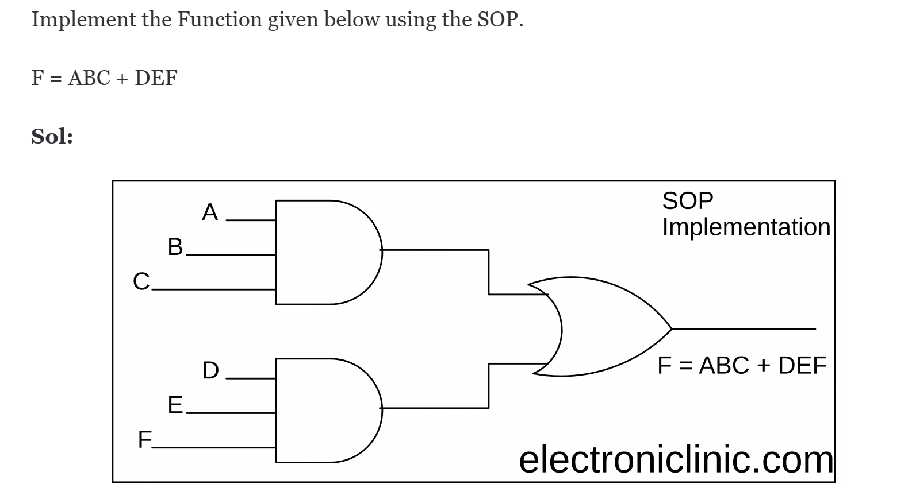

**Example:**

#### **Construct SOP from a Truth Table:**

SOP implementation from a truth table using AND-OR Gates combination.

***Converting SOP Expressions to Truth Table Format***

Develop a truth table for the standard SOP expression.

#### **The Standard SOP Form (SSOP)**

A standard SOP expression is one in which all the variables in the domain appear in each product term in the expression.

For example

BBC is a standard SOP expression.

#### **Steps for Converting SOP to SSOP**

* Find the missing variables for every product term. For example, C is the missing term from the three variable boolean expressions' product term AB.
* Apply the OR operator between the missing variables and its complement. For example, (C+C')
* Now join it with the product term through the AND operator. For example, AB(C+C')
* Repeat all the above steps, that is, from step 1 to step 3, to apply to all the product terms that have missing literals or variables.

***Example***

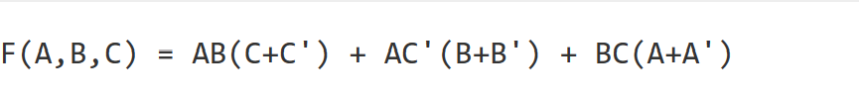

Therefore, in standard SOP form, the final function will be:

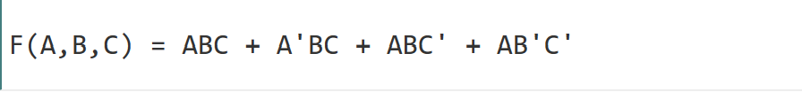

**Product of Sums (POS)**

The product of Sum form is a form in which products of different sum terms of inputs are taken. These are not arithmetic product and sum but they are logical Boolean AND and OR respectively.

**Example:**

the expression (a+b) (b+c+d) (a+c).

#### **Construct POS from a Truth Table:**

#### **Converting POS Expressions to Truth Table Format**

Determine the truth table for the following standard POS expression:

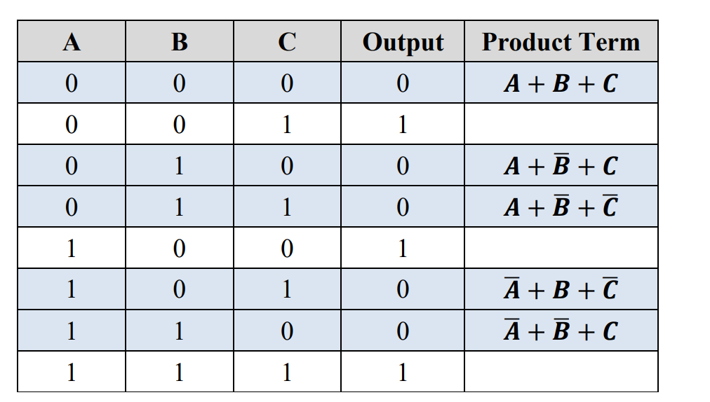

#### **The Standard POS Form (SPOS)**

A standard POS expression is one in which all the variables in the domain appear in each sum term in the expression.

For example

#### **POS to SPOS Conversion Steps**

* Find the missing variable for each sum term.
* Now join the missing variable (in uncomplemented form) and missing variable (in complemented form) with **AND** operator, and then join this term with the **sum term** using **OR** operator.  
  Or, in other words, **OR** each term combined with the term formed by **AND** including the omitted variable and its complement.
* Repeat the process for all the sum terms that have missing variable.
* Simplify the expression to get the boolean expression in standard POS form.

***Example***

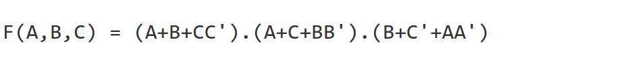

finally, the function in standard POS is defined as:

#### 

#### **Converting Standard SOP to Standard POS**

to convert from standard SOP to standard POS, the following steps are taken:

1. Evaluate each product term in the SOP expression. That is, determine the binary numbers that represent the product terms.
2. Determine all the binary numbers not included in the evaluation in Step 1.
3. Write the equivalent sum term for each binary number from Step 2 and express it in POS form.

FROM project menu analyze circuit

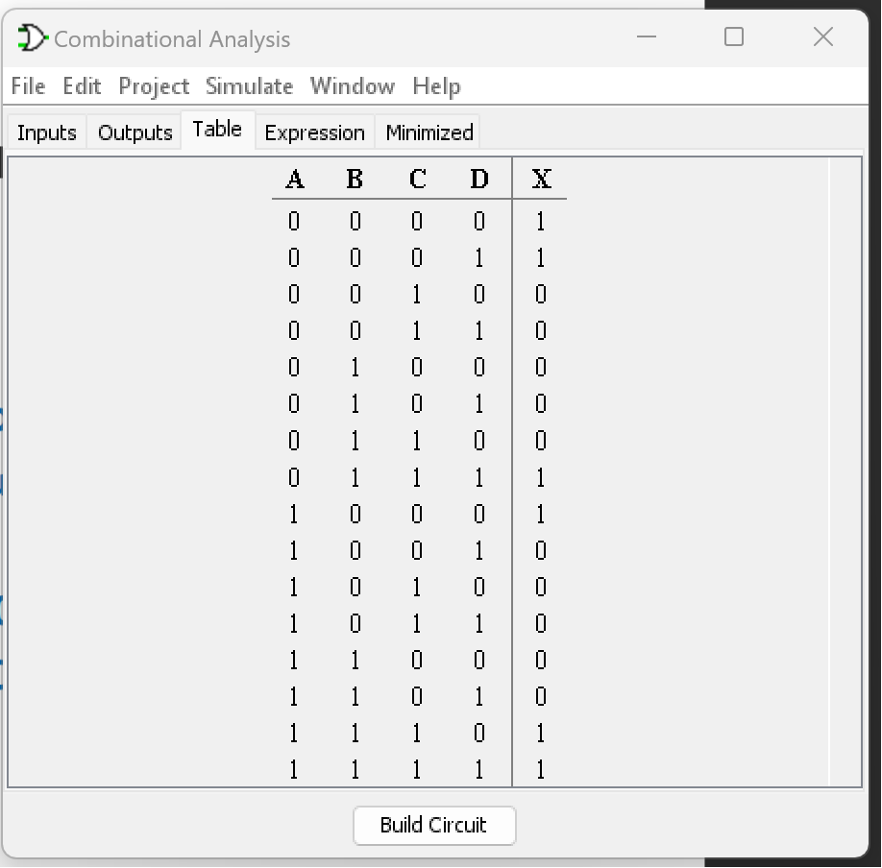

The Boolean equation

FROM project menu analyze circuit

The Boolean equation

The simplified equation

Simplified circuit

Sop form

pos form